**Large Scale Data Analysis ELEC-E5431**

**Name: Nguyen Xuan Binh**

**Student ID: 887799**

--------------------------------------------------------------------------------------------------------------------------------------

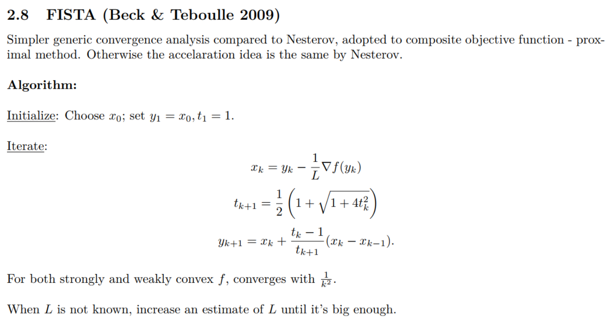

--------------------------------------------------------------------------------------------------------------------------------------

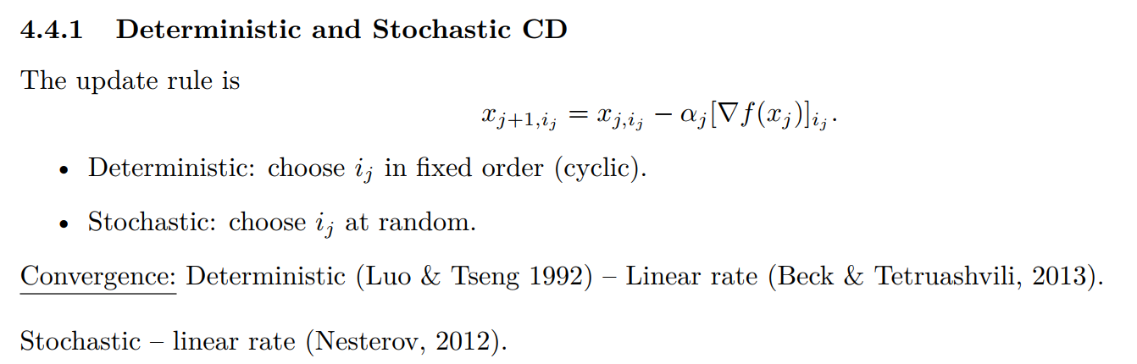

Because my laptop can still invert a matrix of dimension of 10000 pretty fast (20-30 seconds), and the matrix is already very heavy. If I increase the dimension even higher, my laptop will not have enough memory to store the matrix, so I am not sure what is the boundary between the large and small scale in my case. Therefore, I choose dimension 10 as small, 100 as large and 1000 as huge scale, and see how the algorithms perform for each case.

You can see all of the tasks completed below in the attached PDF file generated from the ipynb file. Additionally, you can run the file optimization.ipynb in the zipped project file. This file contains every information, from generating matrix data, algorithm implementations to convergence rate analysis.